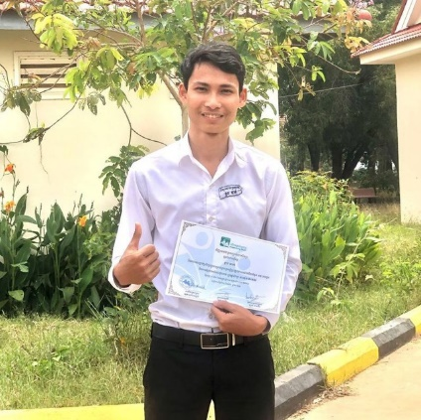 HOUN KLMHUN

DICITAL MARKETINC

**CONTCT**

**ABOUT ME**

Video provides a powerful way to help you prove your point. When you click Online Video, you can paste in the embed code for the video you want to add. You can also type a keyword to search online for the video that best fits your document.

**WOR EXPERIENCE**

* **Junior Digital Marketing**

**June 2023-Present**

* You can also type a keyword to search online
* To make your document look professionally produced,
* Word provides header, footer, cover page,
* text box designs that complement each other.
* **Senior Digital Marketing**

**Soptember 2023-Present**

* You can also type a keyword to search online
* To make your document look professionally produced,
* Word provides header, footer, cover page,
* text box designs that complement each other.

**EDUCATION**

**You can also type a keyword to search online**

To make your document look professionally produced,

**Word provides header, footer, cover page,**

text box designs that complement each other.

PGONE

**+**123-456-7890

EMAIL

ADDREESS

123 Anywhere St, Any City

**SKILLS**

* Program
* Marketing Analysis
* Team work
* Techeology
* Marketing

**LANGUAGE**

* English
* French
* Spanish
* Korean